






PRESSURE INSPECTION SUMMARY REPORT
API 510 Inspection of Pressure Vessel
E1-R3 EXCHANGER

Client : Chemical Specialties (S) Pte Ltd
Location : 31 Ayer Merbau Road, Jurong Island
Project : API Inspection
Project No : LEADS-23-03
Report No : LEADS-23-03-API-05
Date of
Inspection : 04-05 May 2023

Table of Contents
- Introduction
  - Works Brief
  - General Arrangement & Reference
    - Reference Documents
  - Vessel Suitability for Service Statement
    - General Condition
    - Structural Integrity
    - Coating Integrity
    - Hydraulic Integrity
  - Suitability for Service Determination
  - Inspector's Certification
- Vessel Summary
  - Project Scope
  - Vessel Repair Definitions
  - Vessel Repair Recommendations
  - Vessel Design Data
- Inspection Checklists and Summary
  - Vessel External (Online) Inspection
    - Remaining Life Calculations
  - Vessel Internal (Offline) Inspection
- NDT Inspection Reports
  - Visual Inspection Photographs
  - UTG Report

- Equipment and Personnel Certificates
  - Equipment Calibration
  - Personnel Certification
- General Arrangement Drawing

Originated by | P Rajesh (API 510 Certificate: 61416) |   Signature:
Approved by | Sudhan P (General Manager) |     Signature:

Introduction

Works Brief
Leads was engaged as a third-party inspection company to carry out the inspection based on API 510 which encompasses below.
An American Petroleum Institute (API) 510 pressure vessel external inspection for Exchanger E1-R3 at, CSL facility, Jurong Island, Singapore in May 2023 has been carried out. The vessel was in service, scaffolding has been provided to perform external visual inspection & UTG inspection. This inspection complied with the API 510 standard. This vessel inspection included visual inspection of the shell, nozzles, head, foundation and internal inspection. NDT data gathered will be part of the final report.
This report is generated on data gathered from three locations: applicable codes, regulations, and laws; the observed field conditions existent during the API inspection; and material provided in written form by the facility, end-user, or client (e.g., as-builts, previous inspection reports, written transcriptions of conversations with the facility.)
This inspection report is based solely on empirically observable conditions observed during the inspection process and correspondence with the facility or end-user. Information not empirically observable or presented to us in the course of this inspection, but which may be relevant to the inspection’s findings, have not been evaluated or included in this inspection. The API inspector bears no responsibility for findings which could only be ascertained by information not made available to the API inspector.

General Arrangement & Reference

This inspection report is prepared with a photo and name of each item and / or a location for reference. In addition, the report is also complemented with all the necessary equipment and personnel certification to ensure that the job was performed in line with the requirements. Please note the content of the final report and report reference numbers are number numerical in each NDT method, however they are grouped in this summary by NDT method so they may not be sequential in their grouping.

1.2.1 Reference Documents
- API 510 – Pressure Vessel Inspection Code
- Leads NDT Technical Procedures
- General Arrangement Drawing: (CSL-HX-MHI-E1R3-001 Rev 01)

1.3 Vessel Suitability for Service Statement
This report contains all the details and evaluation results used to arrive at this vessel suitability for service determination. Based on the findings and the detailed report below, we have determined that:
- The vessel can continue to operate. However, recommendations are provided for further follow up.

1.3.1 General Condition
Exchanger E1-R3 is Vertical vessel. The vessel is approx. 5530.86 mm tall with a 1035.05 mm outer diameter. Vessel was in operation from 2018.

1.3.2 Structural Integrity
We define vessel structural integrity as the capability of the vessel to remain freestanding, with or without product, under the conditions of its design basis. Structural attributes include the vessel foundation, shell, head and their attachments. Ultrasonic thickness inspections of the shell & head were performed.
Based on our inspection of the accessible components and engineering evaluation, vessel is considered to have suitable structural integrity.

1.3.3 Coating Integrity
We define coating integrity as the interior wetted coating’s ability to provide an impervious, completely continuous film barrier that prevents harmful environmental and service conditions corrosive agents to penetrate to the base metal, which could over time compromise hydraulic integrity.
Although corrosion and coating failures may not indicate structural failures; they present conditions which, in time, can lead to structural integrity failures.
No access to the shell plate due to insulation. Based on our inspection of the accessible components and engineering evaluation, vessel is considered to have suitable coating integrity.

1.3.4 Hydraulic Integrity
Not Applicable as Hydrotest was not part of the scope this time.

1.4 Next Inspection Schedules
External Inspection:
API 510 recommends Unless justified by an RBI assessment, each aboveground vessel shall be given a visual external inspection at an interval that does not exceed the lesser of five years or the required internal/on-stream inspection. It is preferred to perform this inspection while the vessel is in operation.
Internal, On-stream, and Thickness Measurement Inspections:
Unless justified by a RBI assessment, the period between internal or on-stream inspections and thickness measurement inspections shall not exceed one-half the remaining life of the vessel or 10 years, whichever is less. Whenever the remaining life is less than four years, the inspection interval may be the full remaining life up to a maximum of two years.
Based on the thickness measurements, we recommend the below:
- API internal inspection (out-of-service) shall be conducted

  - no later than previous inspection recommendation (shall not exceed 10 years from last internal inspection)

- UTG inspection shall be conducted

  - no later than May 2033 (10 years from May-2023 inspection)

- API external inspection (in-service) be conducted

  - no later than May 2028 (5 years from May-2023 inspection) for a visual inspection

or sooner if a change in condition has occurred.

1.5 Inspector's Certification
I acknowledge that I am familiar with API Standard 510’s provisions; the inspection and evaluation performed on Vessel at CSL facility and certify that the inspection was performed per the API Standard 510 provisions, good engineering practices, and with usual and customary care.

Vessel Summary

2.1 Project Scope
An API 510 vessel inspection has been performed on the vessel. This vessel inspection included external visual inspection of the vessel shell, nozzles, head, foundation (where accessible) & UTG. Following the API 510 inspection’s completion, report with findings is provided detailing all vessel conditions and repair recommendations.

2.2 Vessel Repair Definitions
Mandatory Repairs – repairs that need to be completed before the vessel can be returned to service. Mandatory Repairs consists of any failure / deficiency that has breached the hydraulic and/or structural integrity of the vessel, and/or presents an imminent danger to personnel and/or adjacent structures.

Non-Mandatory Recommended Repairs Preceding Return-To-Service – repairs that do not meet the requirements of being a Mandatory Repair, but will help maintain or improve vessel operability / serviceability, or else are required to meet current codes. Repairs noted under this category are recommended for performance prior to the vessel being returned to service.

Future Non-Mandatory Recommended Repairs – repairs that do not meet the requirements of being a Mandatory Repair, but will help maintain or improve vessel operability / serviceability, or else are required to meet current codes. Unlike the Non- Mandatory Recommended Repairs Preceding Return-To-Service, Future Non- Mandatory Recommended Repairs are not being recommended for performance prior to the vessel being returned to service.

Recurring Maintenance Recommendations - actions that should be taken on a recurring basis

2.3 Vessel Repair Recommendations
The API 510 inspection has resulted in the following repair conditions:

Mandatory Repairs Preceding Return To Service
I.1 | None
Non-Mandatory Recommended Repairs Preceding Return-To-Service
II.1 | None
Future Non-Mandatory Recommended Repairs
III.1 | Recommend to fix the damaged insulation at the middle section.
III.2 | Recommend to open all the nozzle and supporting bracket insulation area for the future API external inspection.
Recurring Maintenance Recommendations
IV.1 | Let the fire and safety systems be checked on an annular base by a safety engineer.
IV.2 | Perform proper housekeeping on a regular base.
IV.3 | Perform visual and UT inspections as per Inspection Interval Recommendation.

2.4 Vessel Design Data

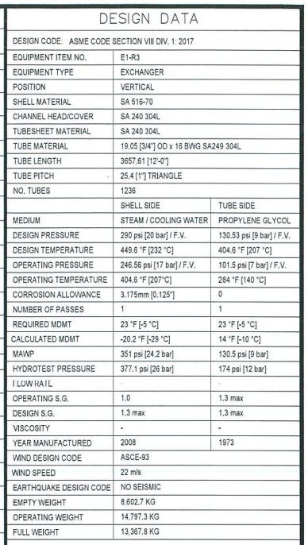

3.0 Inspection Checklists and Summary
The following inspection summaries list all noted deficiencies and the governing criteria with which they fail to comply fully.

3.1 Vessel External (Online) Inspection

Ladders, Stairways, Platform, Walkways (API 572 Sec 9.3.2) :
1 | Ladder attachments to concrete base (corrosion, broken): | NA
2 | Bolts and fasteners on stairways and ladder stringers (tightness and corrosion): | NA
3 | Welds on stairways and ladder stringers (corrosion, broken): | NA
4 | Welds on spiral stairway to shell supports (corrosion, broken): | NA
5 | Stairways and ladders (corrosion, broken): | NA
6 | Stairways and ladders (coating or paint failure): | NA
7 | Attachment welds of handrails to stairways (corrosion, broken): | NA
8 | Tubular / solid bar stairway handrails (corrosion, pitting, paint failure): | NA
9 | The condition of flooring on platforms and walkways | NA
10 | Crevice corrosion around the heads of bolts and nuts at bracket connections | NA
11 | Loose or broken parts found any | NA
Foundation and Supports (API 572 sec 9.3.3)
12 | Plumpness of column supporting spherical tank | NA
13 | Settlement Survey | NA
14 | Condition of connected pipe lines due to settlement | NA
15 | Misalignment of the foundation with the surrounding paving or ground due to settlement | NA
16 | Check for deterioration such as spalling, cracking, and settling on the foundation | NA
Anchor Bolts (API 572 sec 9.3.4)
17 | Check for deterioration of the anchor bolt below the base plate | NA
18 | Distortion of anchor bolts due to foundation settlement if any | NA
19 | Tightness of nuts | NA
Concrete Support (API 572 sec 9.3.5)
20 | Sealing condition between concrete support and vessel shell | NA

Steel Support (API 572 sec 9.3.6)
21 | Check for corrosion, distortion, and cracking | 2
22 | Remaining thickness of (Skirts, Columns and bracing ) | U/A
23 | Check for buckling, Excessive Deflection (measurement by straightedge or plumb line) | 2
24 | NDE (MT /PT) result of attachment weld supporting tank | NA
25 | Insulation condition of supporting skirts | NA
26 | Piping attachment to Spherical tank (Check for evidence of distortion due to pipe movement) | NA
27 | Fireproofing Condition (Bulge , Rust stain, Crack) | 2
Guy Wires (API 572 sec 9.3.8)
28 | Check for corrosion and broken strands | NA
Nozzles (API 572 sec 9.3.9)
29 | Check for distortion due to settlement | 2
30 | Nozzles painting / coating condition | 2
31 | Nozzles corrosion pitting condition | 2
32 | Check for flange leak (discoloration to the vessel, insulation, fireproofing, or paint, or damage) | 2
33 | Thickness survey reading | 2
Grounding Connections (API 572 sec 9.3.10)
34 | Tightness, positive bonding to the vessels, and corrosion, Continuity of wires | 2
35 | Recommended Resistance achieved ( 5 to 25 Ohms) | NA
Auxiliary Equipment (API 572 sec 9.3.11)
36 | Evidence of Vibration if any | 2
37 | Drain lines and other connected piping | 2
38 | Gauges for liquid level, pressure, and temperature and other instruments | 2
39 | Safety and relief valves | NA
40 | External water sprays and other fire-fighting equipment | NE
41 | Instrument or utility stations | NA
42 | Structural steel for platforms, supports, and lifting lugs | NA
Protective Coatings and Insulation (API 572 sec 9.3.12)
43 | Check for Rust spots, blisters, and film lifting | 2
44 | Condition of Insulation | 3

External Metal Surfaces (API 572 sec 9.3.13)
45 | Picking, scraping, and limited hammering | U/A
46 | General external painting / coating condition | U/A
47 | General external corrosion pitting condition | U/A
48 | Thickness survey reading | 2
49 | NDE ( MT / PT) results of support attachment location | NA
50 | Condition of weld joints wherever accessible (lower and upper equator plate, lower and upper temperate, top and bottom center crown weld joints) | 2
Roof / /Shell Appurtenances
51 | Manway covers secured in place, condition: | 2
52 | Roof nozzles condition: | 2
53 | Roof Platform condition: | NA

Legend:
1 | Good Condition | 3 | Repair or alteration recommended | U/A | Un-assessable
2 | Satisfactory Condition | 4 | Repair or alteration required | NE | None Evident
xx | Not to Code |  |  | N/A | Not applicable

Comments:
- It’s an insulated vessel, inspection was conducted for CUI and from UTG ports In general, minor rust was observed on nozzles, top flange cover, some portion of the shell.
- Minor damage on the insulation at the mid-section, recommend to fix it.

3.1.1 Remaining Life Calculations:
SHELL:
When P does not exceed 0.385SE, the following formula shall apply:

$$t=\frac{PR}{SE-0.6P}*25.4$$
- t_{min} is the minimum required thickness in mm,
Material - SA 516 Grade 70N
P (internal design pressure, lbf/in.²) – 290
R (inside radius, in.) – 20.375
S (Max. allowable stress, lbf/in.²) – 20000 (for temp 500ºF, Ref ASME Sec II – part D – Table 1A)
E (Joint Efficiency) – 0.70 (no RT information available)

t=10.86mm
Corrosion allowance from drawings = 3.18mm

Actual lowest thickness – 18.97mm (0.744 in)

Maximum Allowable working pressure (MAWP) for the noted thickness:
$P=\frac{SEt}{R+0.6t}$

P = 500.83 psi

CHANNEL CAP:

$$t=\frac{PD}{2SE-0.2P}*25.4$$
- t_{min} is the minimum required thickness in mm,
Material - SA 240 304L
P (internal design pressure, lbf/in.²) – 130.53
R (inside radius, in.) – 20.375
S (Max. allowable stress, lbf/in.²) – 14700 (for temp 500ºF, Ref ASME Sec II – part D – Table 1A)
E (Joint Efficiency) – 0.70 (no RT information available)

t=6.57mm
Corrosion allowance from drawings = 3.175mm

Remaining Life = t_{actual}-t_{required} / corrosion rate

Plate No. | Original Thickness (mm) | Actual lowest Thickness (mm) | Wall loss (mm) | Years of Service | Long Term Corrosion Rate (mm/year) | Min. required thickness (mm) | Remaining Life (Years) | Next recommended UTG
Shell | 19.05 | 18.97 | 0.08 | 5 | 0.016 | 10.86 | 309 | 10 years
Top Channel Cap | 9.53 | 9.07 | 0.46 | 5 | 0.095 | 6.57 | 26 | 10 years
Bottom Channel Cap | 9.53 | 9.35 | 0.18 | 5 | 0.036 | 6.57 | 77 | 10 years
- UTG report number: LEADS-23-CSL-UTG-14
- Note 1: Remaining life cannot be calculated as the actual thickness is higher than the design thickness.

3.2 Vessel Offline Inspection

Internal Nozzles
1 | Check for distortion due to settlement | NA
2 | Check for flange leak (discoloration to the vessel, insulation, fireproofing, or paint, or damage) | NA
3 | Thickness survey reading | NA
Internal Linings / Coatings / Cladding
4 | Check for Rust spots, blisters, and film lifting | NA
5 | Check for cracks, openings | NA
6 | Others | NA
Internal Metal Surfaces
7 | Picking, scraping, and limited hammering | NA
8 | NDE ( MT / PT) results of support attachment location | NA
9 | Condition of weld joints wherever accessible (lower and upper equator plate, lower and upper temperate, top and bottom center crown weld joints) | NA
Internal Evidence of Corrosion
10 | Evidence of Atmospheric corrosion, caustic embrittlement, hydrogen blistering, and soil corrosion | NA
Internal Appurtenances
11 | Manway covers secured in place, condition: | NA
12 | Attachment welds condition | NA
13 | Baffle / Weir / Impingement Plates / Mixer /Agitator / Heating coil / Thermowells / Tray / Distributor (where applicable) condition: | NA

NDT Inspection Reports
  - Visual Inspection Photographs
  - UTG Report

  - Visual Inspection Photographs
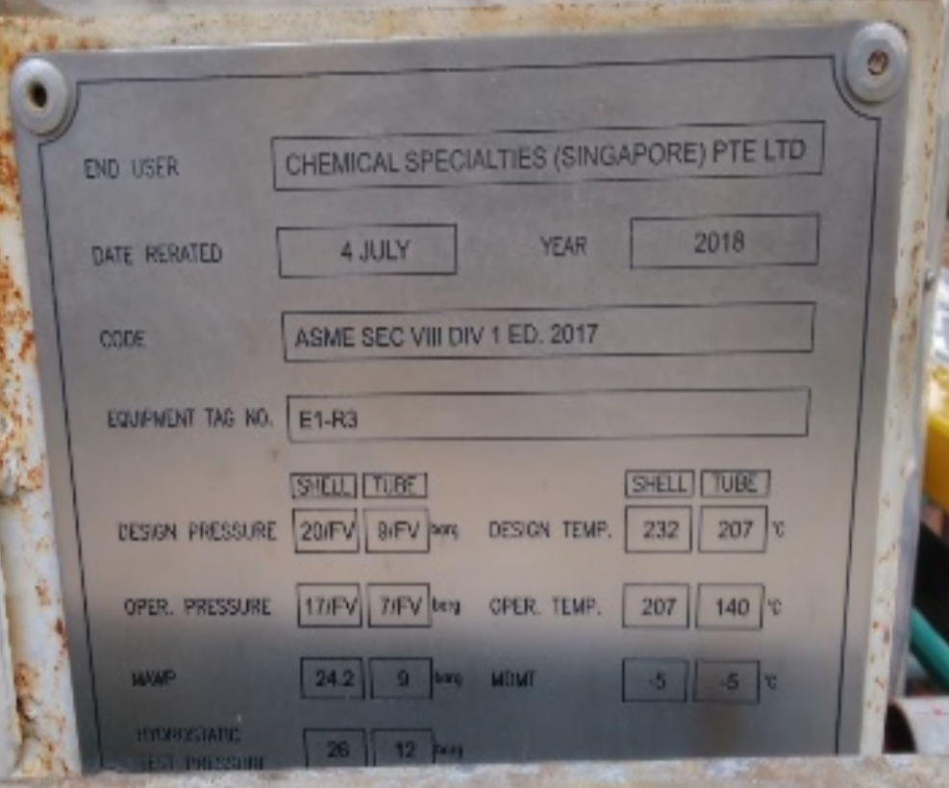
Photo 1: Name plate observed in satisfactory condition.
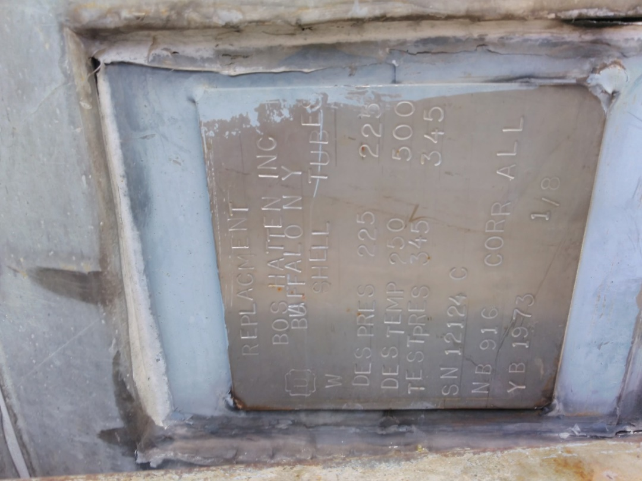
Photo 2: Design Identification plate was observed in satisfactory condition

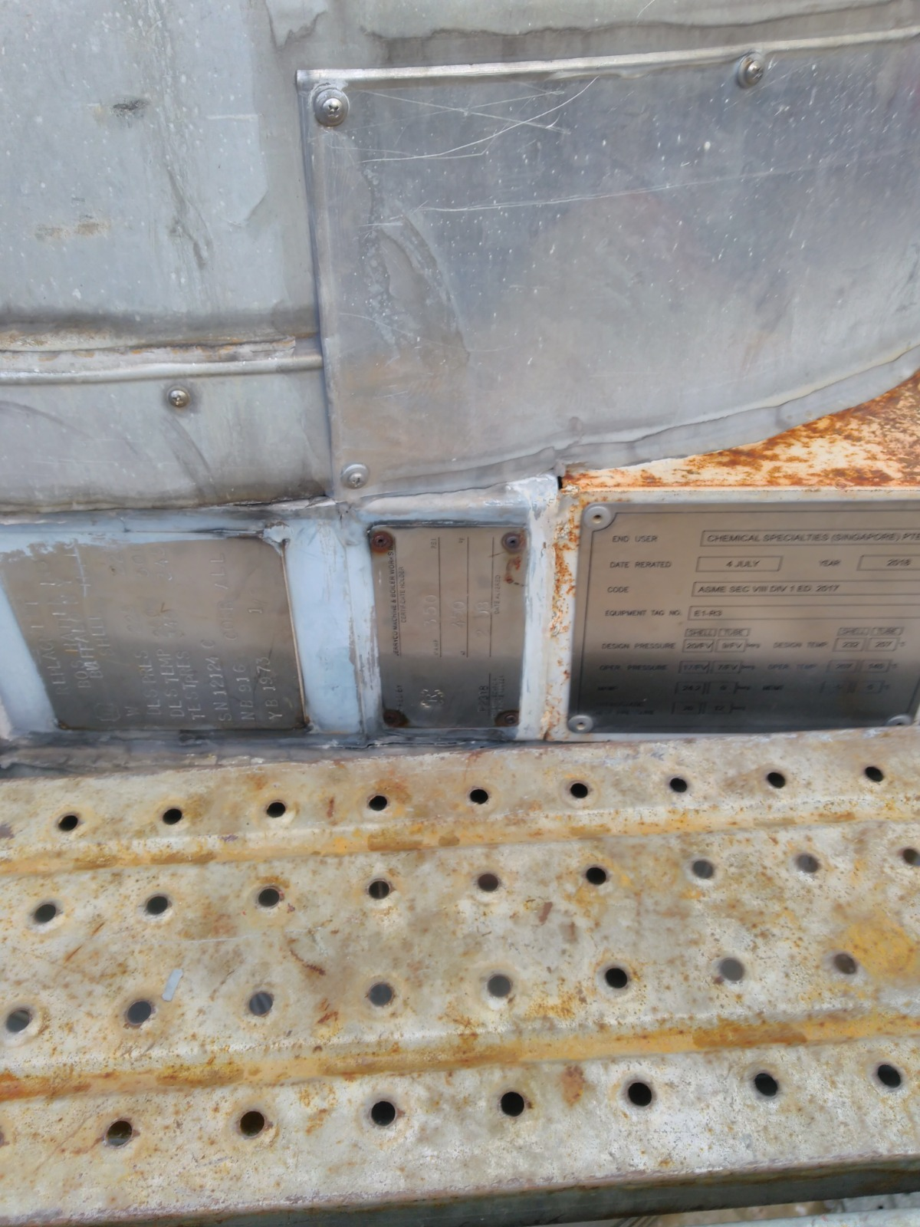
Photo 3: Tank identification plate was observed in satisfactory condition
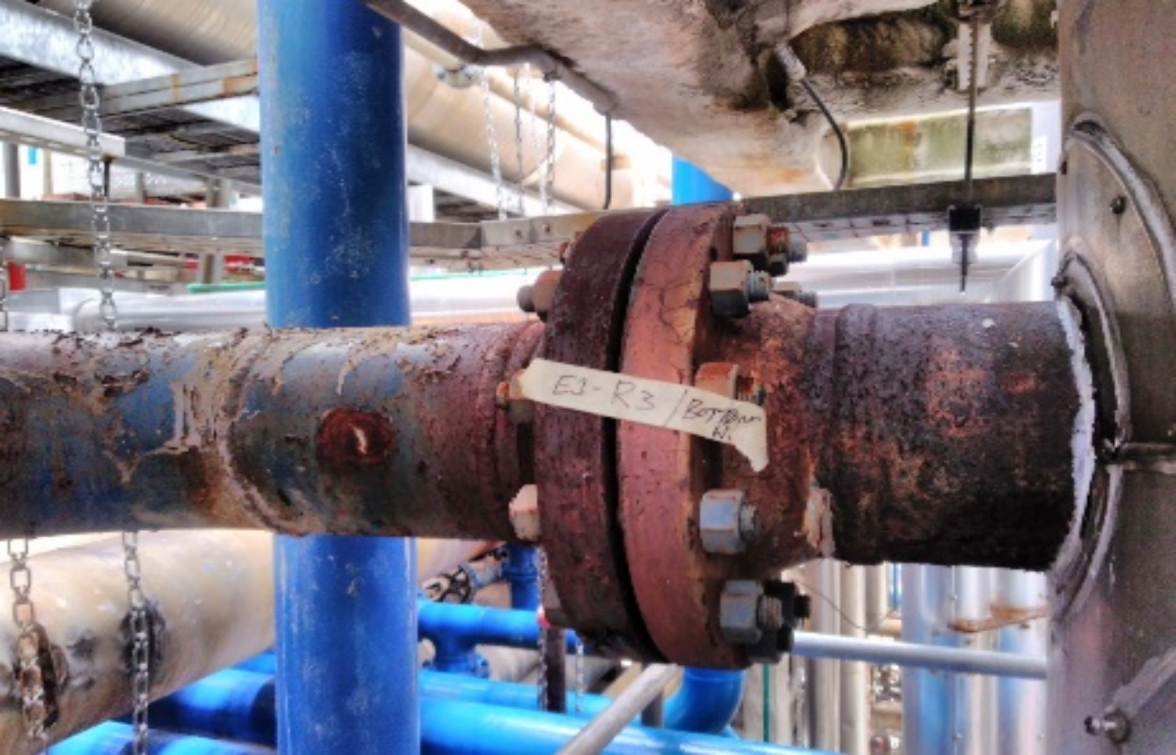
Photo 4: Bottom Shell nozzle were observed with minor corrosion

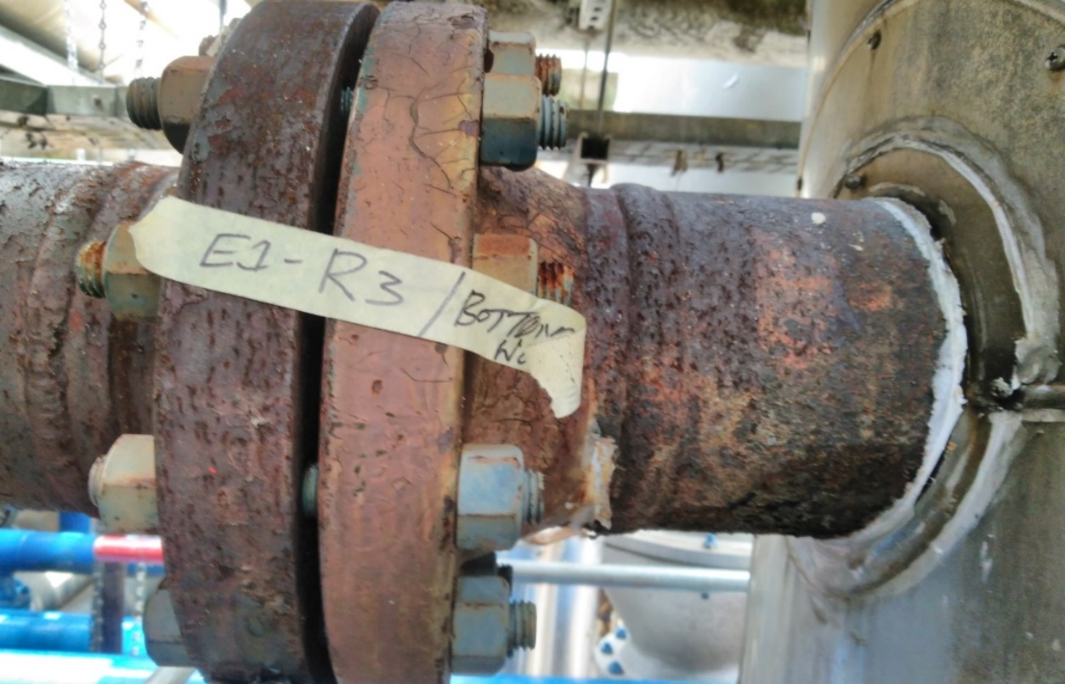
Photo 5: Bottom Shell nozzle were observed with minor corrosion
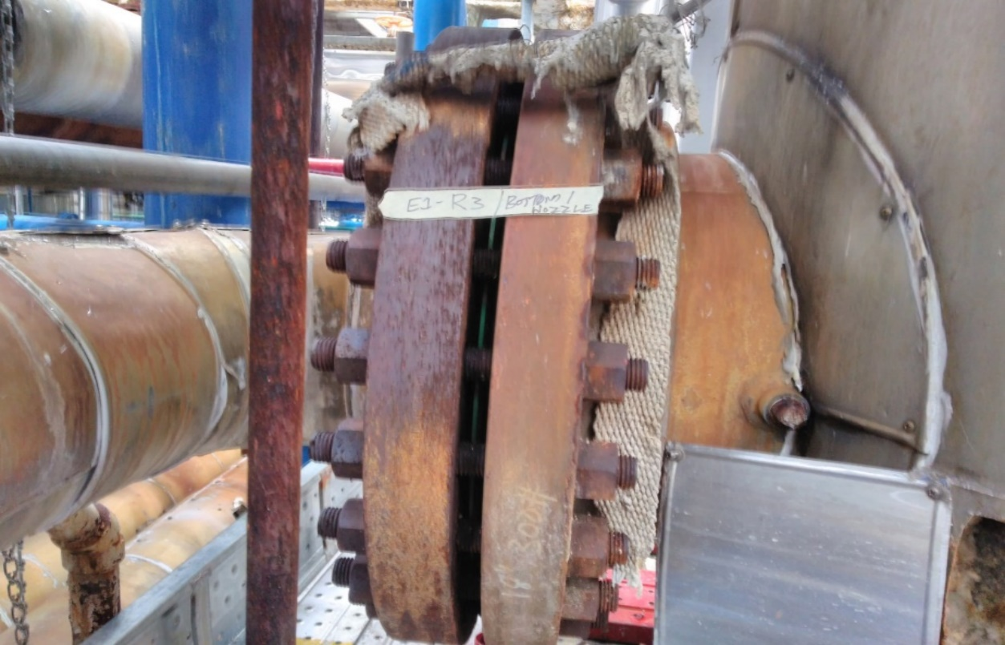
Photo 6: Bottom Shell nozzle were observed with minor rusting

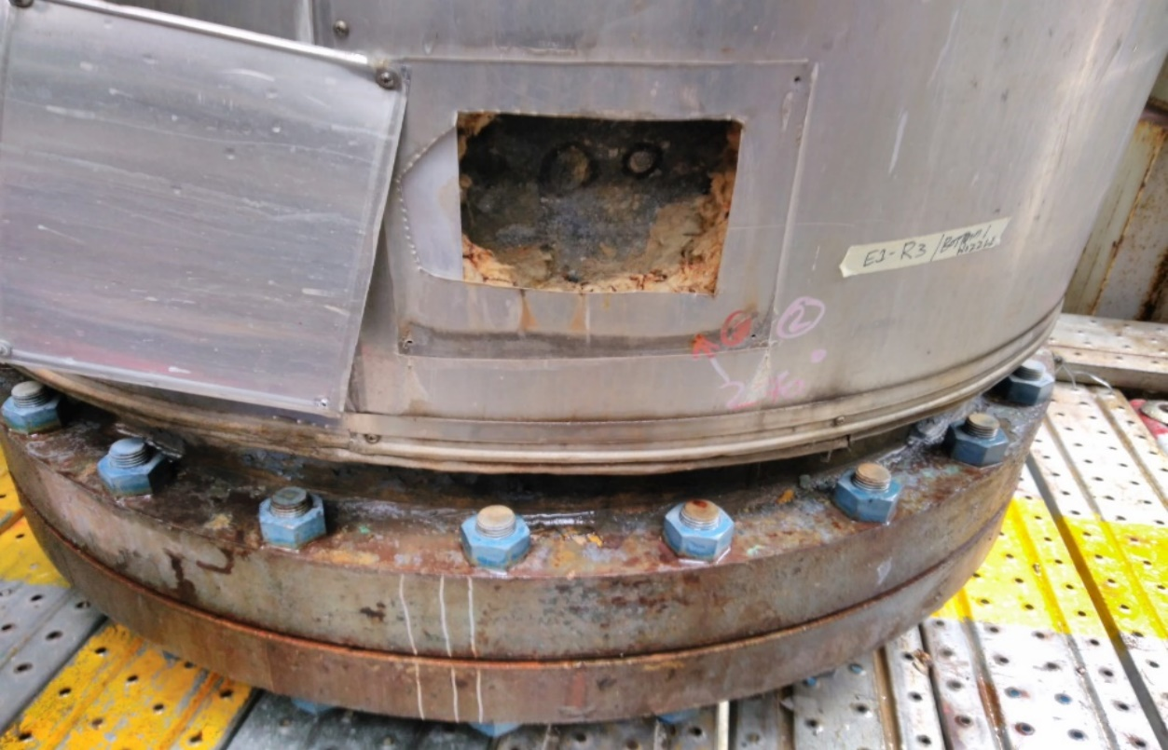
Photo 7: Bottom Shell was observed in satisfactory condition through the insulation window
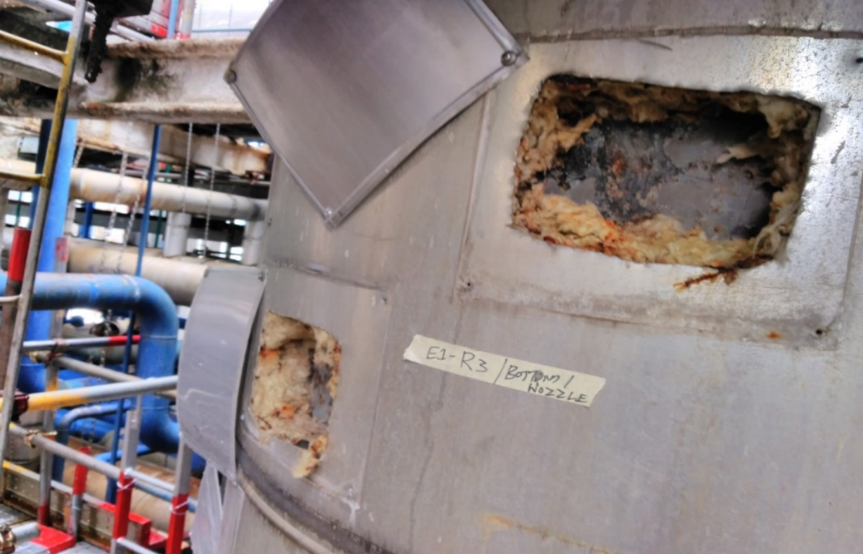
Photo 8: Bottom Shell was observed in satisfactory condition through the insulation window

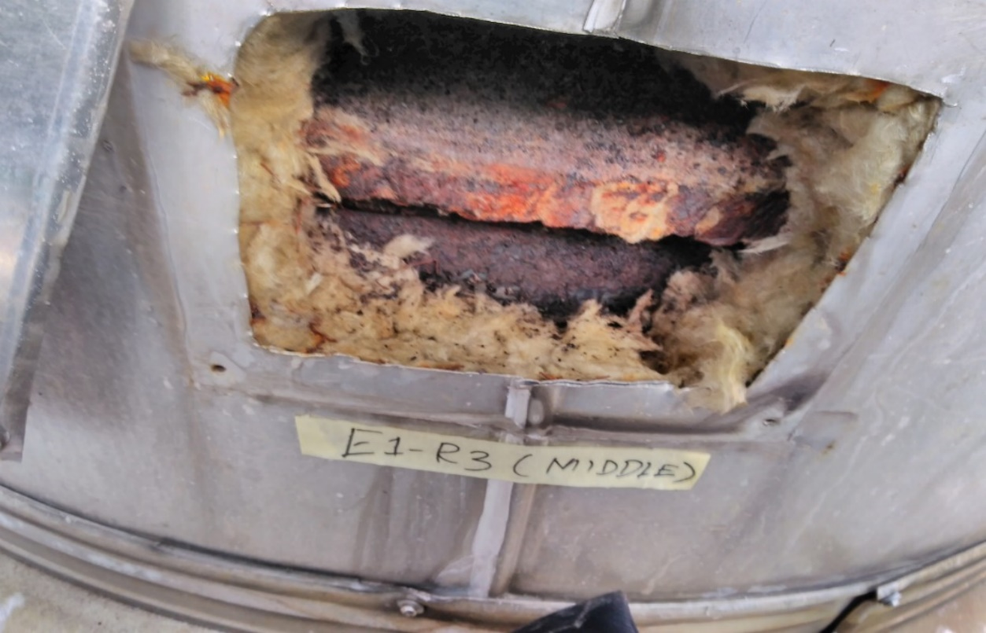
Photo 9: Middle Shell was observed with minor rust through the insulation window
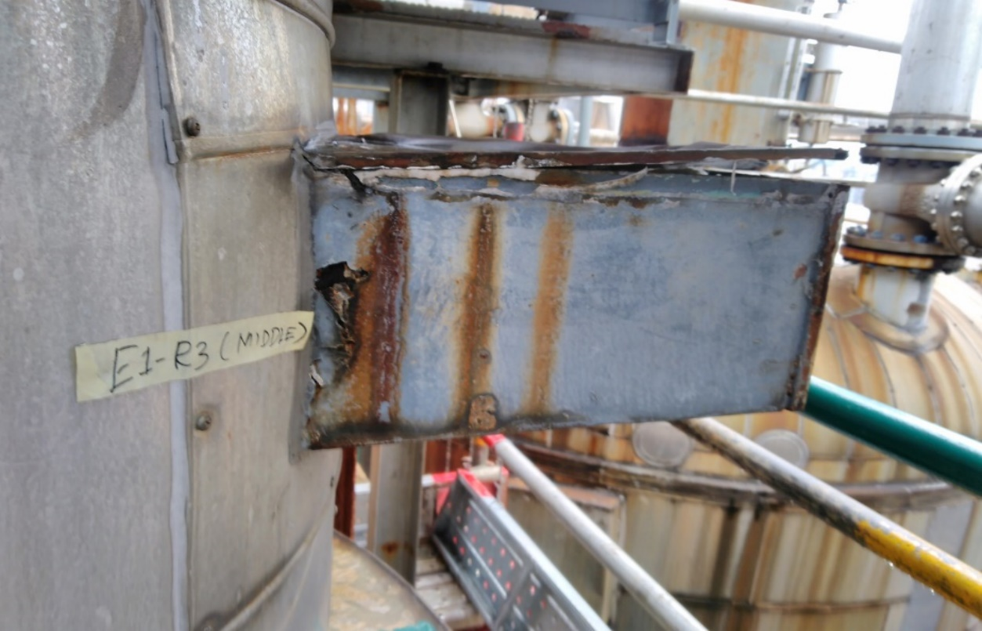
Photo 10: Support Bracket was noticed in damaged condition.

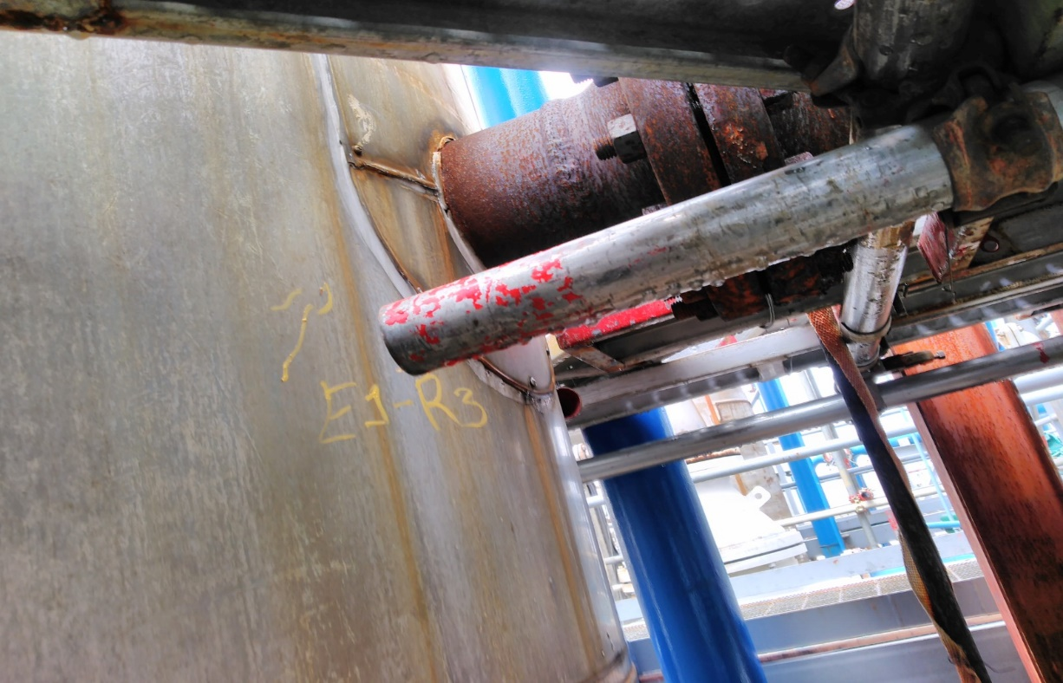

Photo 11: Shell Nozzle was observed with minor rust.
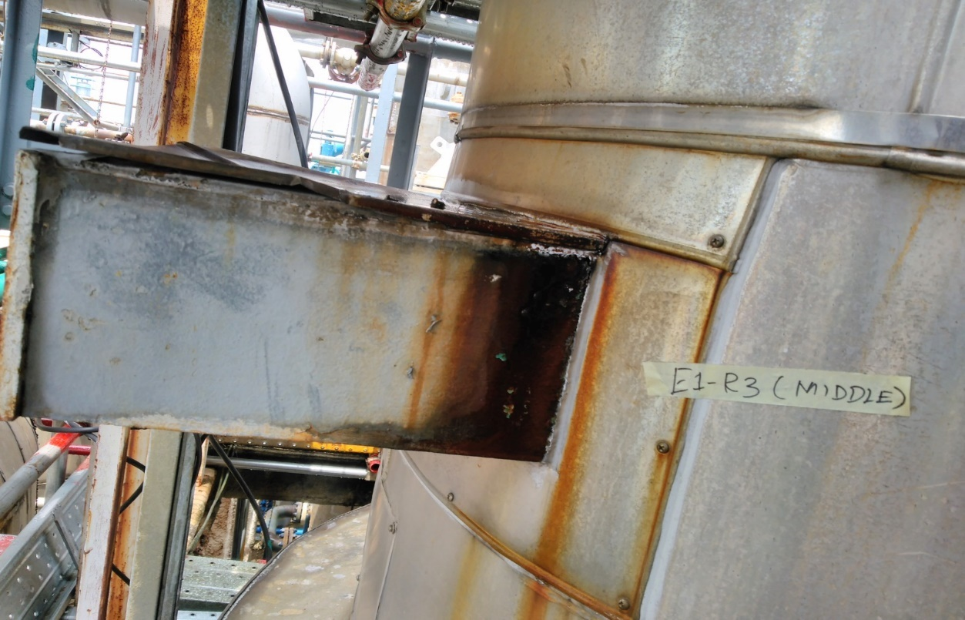
Photo 12: Support bracket was observed in satisfactory condition

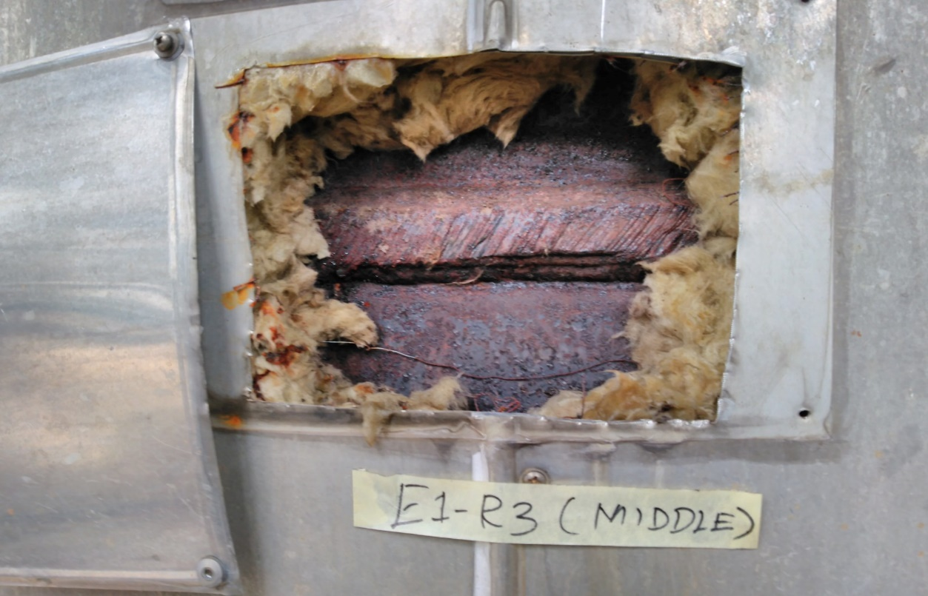

Photo 13: Middle Shell was observed with rust through the insulation window
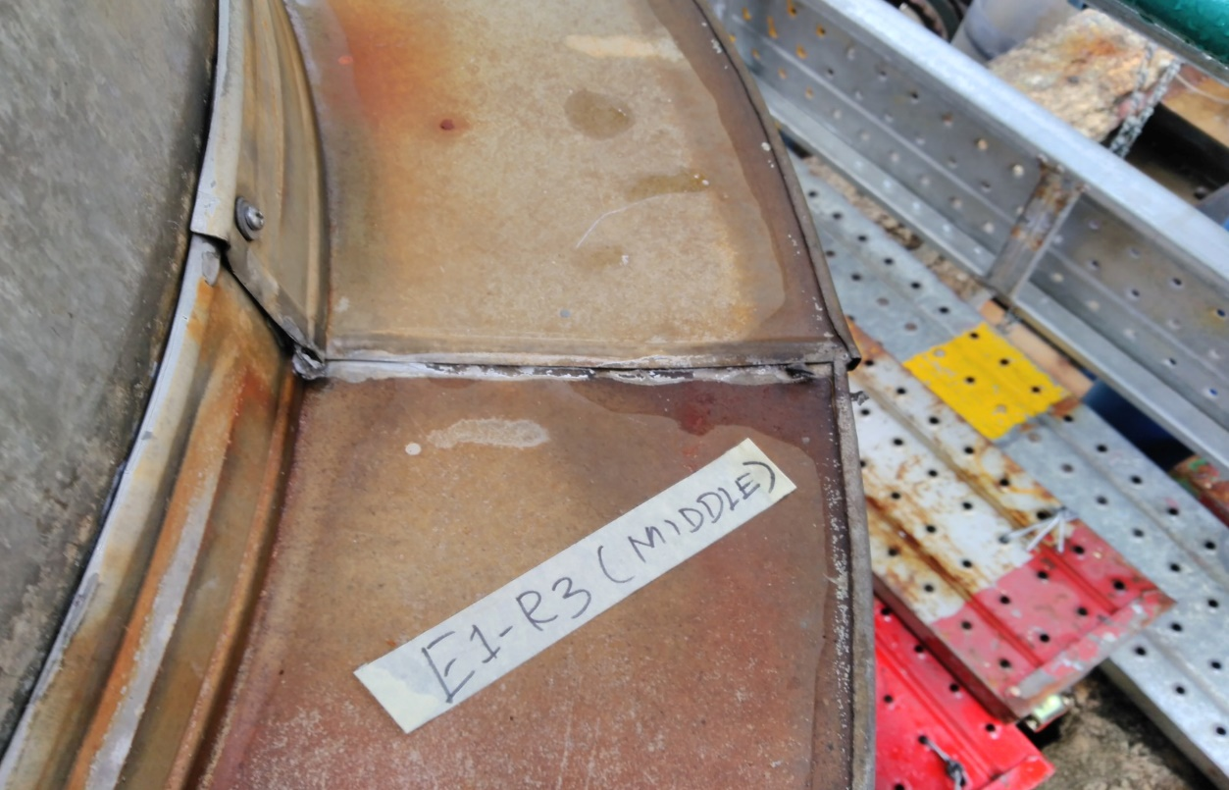
Photo 14: Flange attachment was in satisfactory condition

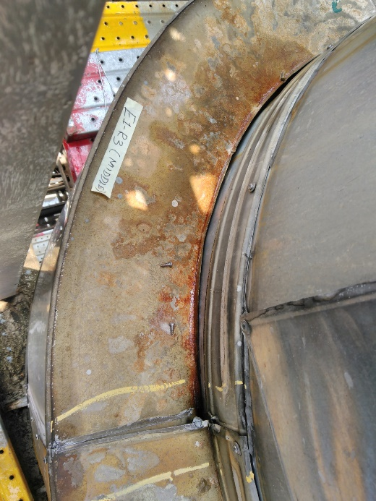

Photo 15: Flange attachment was in satisfactory condition
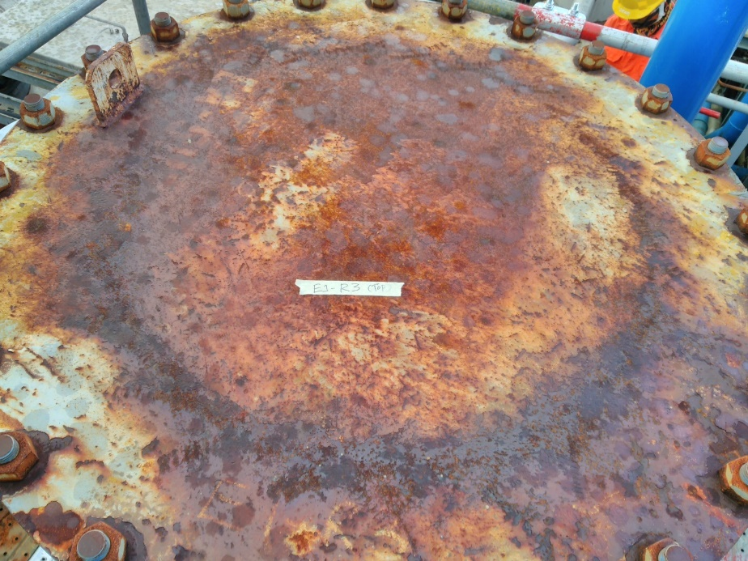
Photo 16: Top dish flange was observed with surface rust.

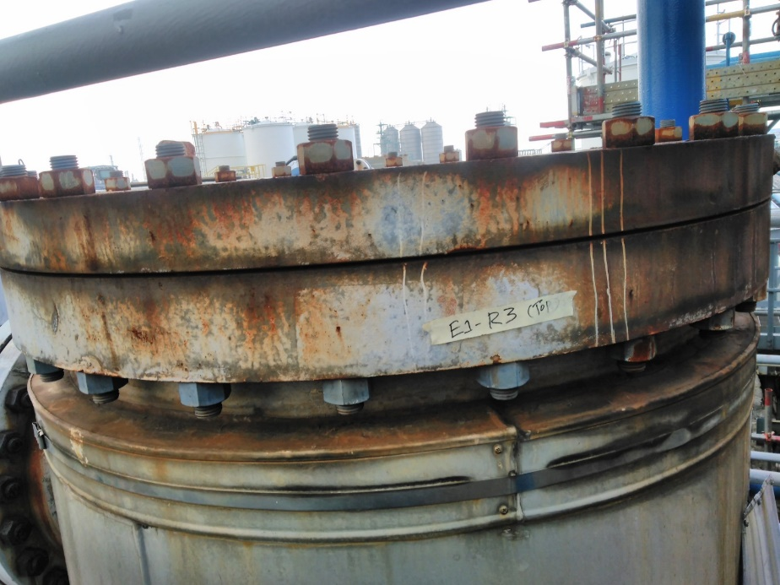

Photo 17: Top area Nozzle was observed in satisfactory condition
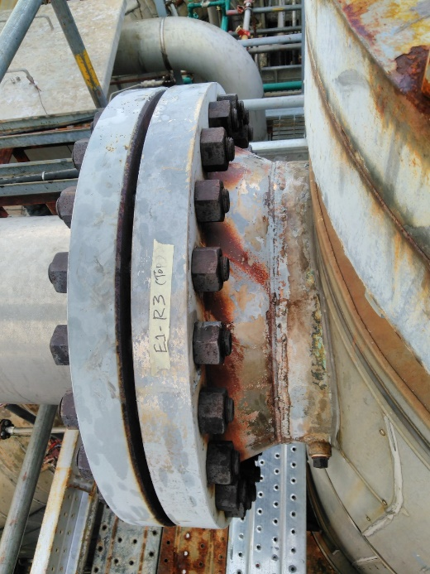
Photo 18: Top area Nozzle was observed in satisfactory condition

  - Ultrasonic Thickness Measurement Report

Equipment and Personnel Certificates
  - Equipment Calibration
  - Personnel Certification

  - Equipment Calibration

  - Personnel Certification

- General Arrangement Drawing

